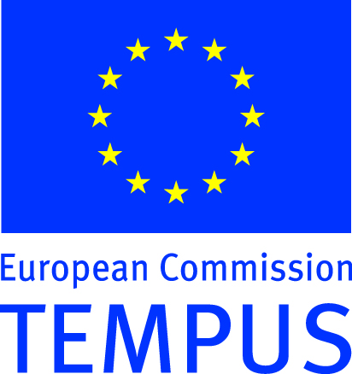
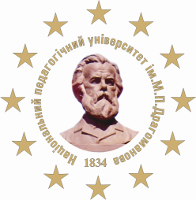
TEMPUS PROJECT
Educational Measurements
Adapted to EU Standards

We invite you to participate in the

INTERNATIONAL FORUM OF PROFESSIONALS IN THE INDUSTRY OF EDUCATIONAL MEASUREMENTS

01 June 2012, KYIV (UKRAINE)
Organized by: The Ministry of Education and Science, Youth and Sports of Ukraine, National Academy of Sciences of Ukraine, the National Pedagogical Dragomanov University (Institute of Informatics), Nizhyn State Mykola Gogol University, Kirovograd State Pedagogical University named after Volodymyr Vinnichenko, the Mälardalen University (Sweden), Helsinki University of Technology (Finland), the University of Rome “La Sapienza” (Italy), the University of Cologne (Germany).
The Forum will be held within the framework of the EU Tempus Project "Educational Measurements Adapted to EU Standards".

Topics of the Forum:
- Innovative Educational Technologies under European Integration of Educational Systems.
- Innovative experience in constructing and administrating of educational tests.
- Training and retraining of specialists in the field of educational measurements.
- Theoretical principles of educational measurements.
- Problems of "Educational Measurements" teaching.
- Information technology in pedagogical testing.
- The national system of entrance tests and monitoring the quality of education.
We invite the representatives of state educational institutions, centers for monitoring of the quality of education, researchers in the field of educational measurements, university professors. During the forum the leading experts from many countries will deliver lectures, short communications, and share experiences.

Organizing Committee:
Andruschenko V.P. (Conference Chairman, Rector of National Pedagogical Dragomanov University), Silvestrov D.S. (Co-Chairman, Co-chairman, chief project coordinator, Professor at Stockholm and Malardalen University, Sweden), Bekh V.P. (Conference Vice-Chairman, Senior Pro-Rector of National Pedagogical Dragomanov University), Padalka O.S. (Pro-Rector for Economy and Teaching and Educational Affairs, National Pedagogical Dragomanov University), Sergienko V.P. (Conference Vice-Chairman, Director of scientific and methodological center for monitoring the quality of education, National Pedagogical Dragomanov University), Volynka G.I. (Pro-Rector for Scientific Affairs, National Pedagogical Dragomanov University), Kudin A.P.. (Pro-Rector for distance education courses and innovative technologies, Director Director of the Institute of Informatics, National Pedagogical Dragomanov University), Lavrynenko V.G.. (Pro-Rector for International Affairs, National Pedagogical Dragomanov University), Kukhar L.O. (Secretary, Post Graduate Student of National Pedagogical Dragomanov University.
Programme Committee
Silvestrov D.S. (Co-Chairman, Västerås, Sweden), Bondarenko S.I. (Co-Chairman, Kyiv, Ukraine) Borysenko O.D. (secretary, Kyiv, Ukraine), Silvestrova E.D. (Västerås, Sweden), Kovalchuk Y.O. (Nizhyn, Ukraine), Sergienko V.P. (Kyiv, Ukraine), Avramenko O.V. (Kirovograd, Ukraine), Valkeila E. (Helsinki, Finland), Manca R. (Rome, Italy), Shmidli H. (Cologne, Germany), Horbachuk I.T. (Kyiv, Ukraine), Zhaldak M.I. (Kyiv, Ukraine), Liashenko O.I. (Kyiv, Ukraine), Pratsiovyty M.V. (Kyiv, Ukraine), Rakov S.A. (Kyiv, Ukraine), Shut M. I. (Kyiv, Ukraine).
Working languages: Ukrainian, Russian and English.
To confirm participation in the Forum, please fill out the registration form on the web site fm.ndu.edu.ua until 01 April 2012
The Program and materials of forum will be published. Abstracts (Microsoft Word file, title of the communication, author(s), affiliation, text of abstract, references, 1 page) have to be sent before 01 May 2012 by e-mail to address forum_2012@i.ua.
Forum will be held at the National Pedagogical University named after M.P. Dragomanov (Str.Pirogov, 9, assembly hall of the main building).
In the frame of the Forum the master classes and presentation of publications of the leading specialists in the field of Educational Measurements will be organized. Participants will be provided by the materials on the problems of Educational measurement (in the electronic form) and Certificates of participation. An interesting cultural program is foreseen.
For information, please call: +380-44-239-30-24, +380-44-235–15-43 (fax), 380-99-298-35-68 (mob.). The project site: fm.ndu.edu.ua.

